Design Document
Individual Project

Deron Barker
400014686

Design Documentation
Architectural Design
The framework used for the Personalized Note System (PNS) is the Laravel framework. Laravel is based on the MVC (Model-View-Controller) architectural design pattern and Service-Oriented Architecture (SOA). It also uses RESTful Web Services to implement APIs for web-based applications.
- MVC Pattern:
- Models: Handle data and business logic.
- Views: Manage the user interface (UI).
- Controllers: Handle requests and coordinate between Models and Views.
- Service-Oriented Architecture (SOA):
Laravel’s Service Container and Service Providers allow different application functions to be built independently with well-defined interfaces, improving modularity and maintainability.
- RESTful Web Services:
These are used to allow the PNS to interact with external applications through APIs while ensuring security and standard communication protocols.
System Interface
The system interface comprises the user interface (UI) and the web routes for the resource as described in the following sections.

User Interface
Landing Page
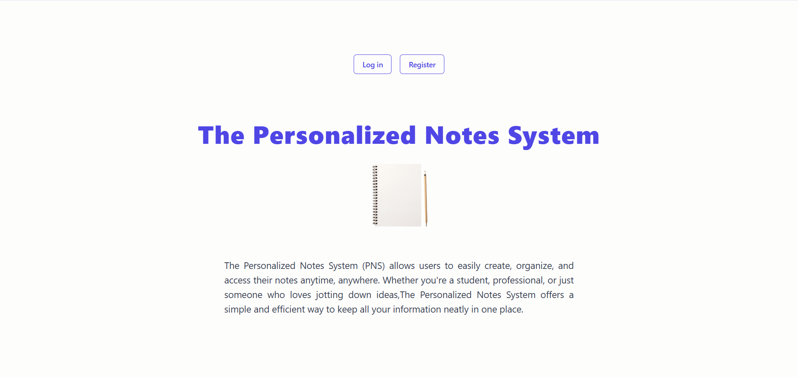
Figure 1 - Home Page
The first page users see. Provides information about the system and allows navigation to login or register.
Login Page
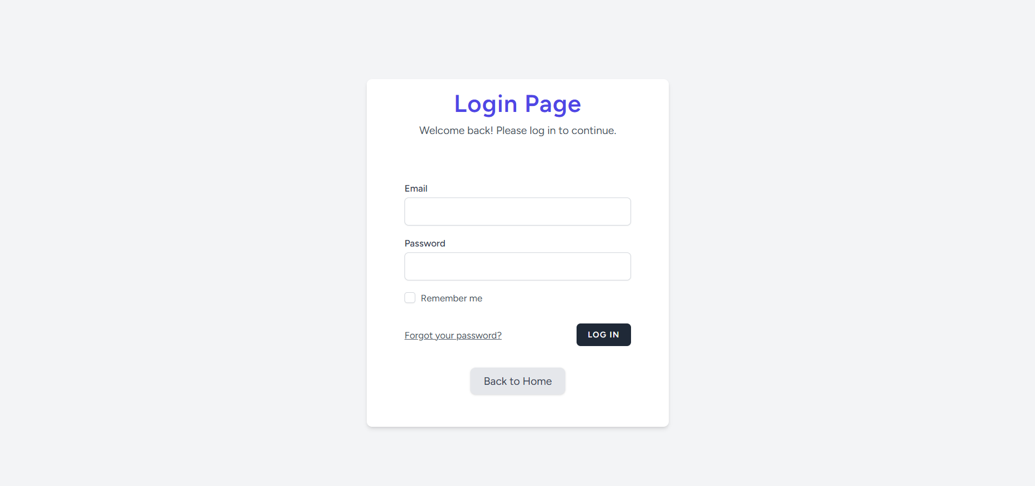
Figure 2 - Login Page
Allows existing users to access their accounts by entering their email and password.
Registration Page
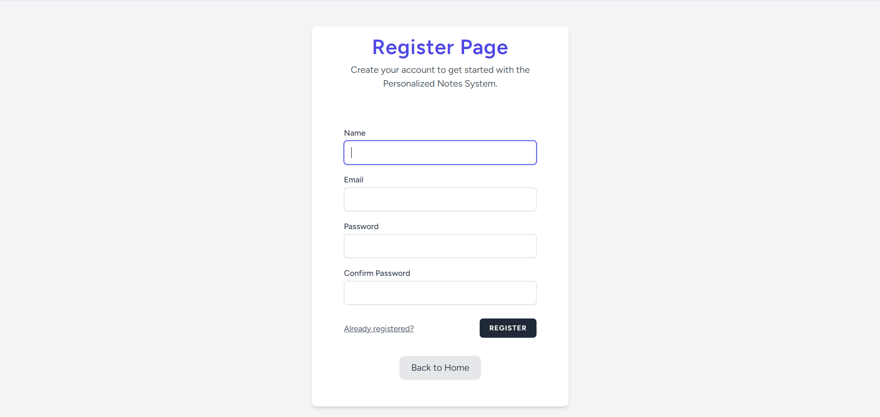
Figure 3 - Registration Page
Allows new users to create an account. Users are assigned the default role of Student upon registration.
Home Page
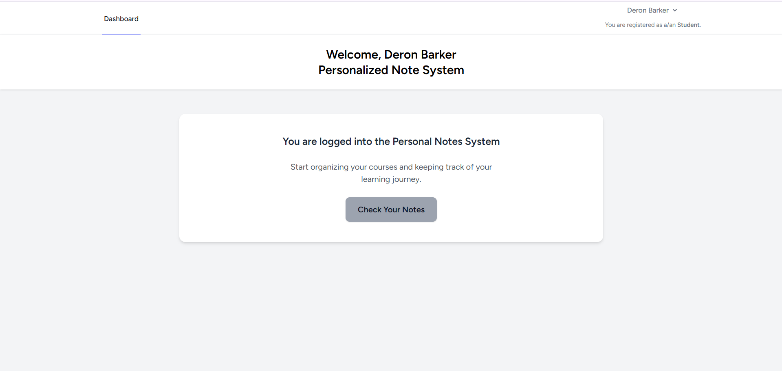
Figure 4 - Home Page
The main dashboard after login. Displays options for viewing, creating, editing, and deleting notes.

Index Page
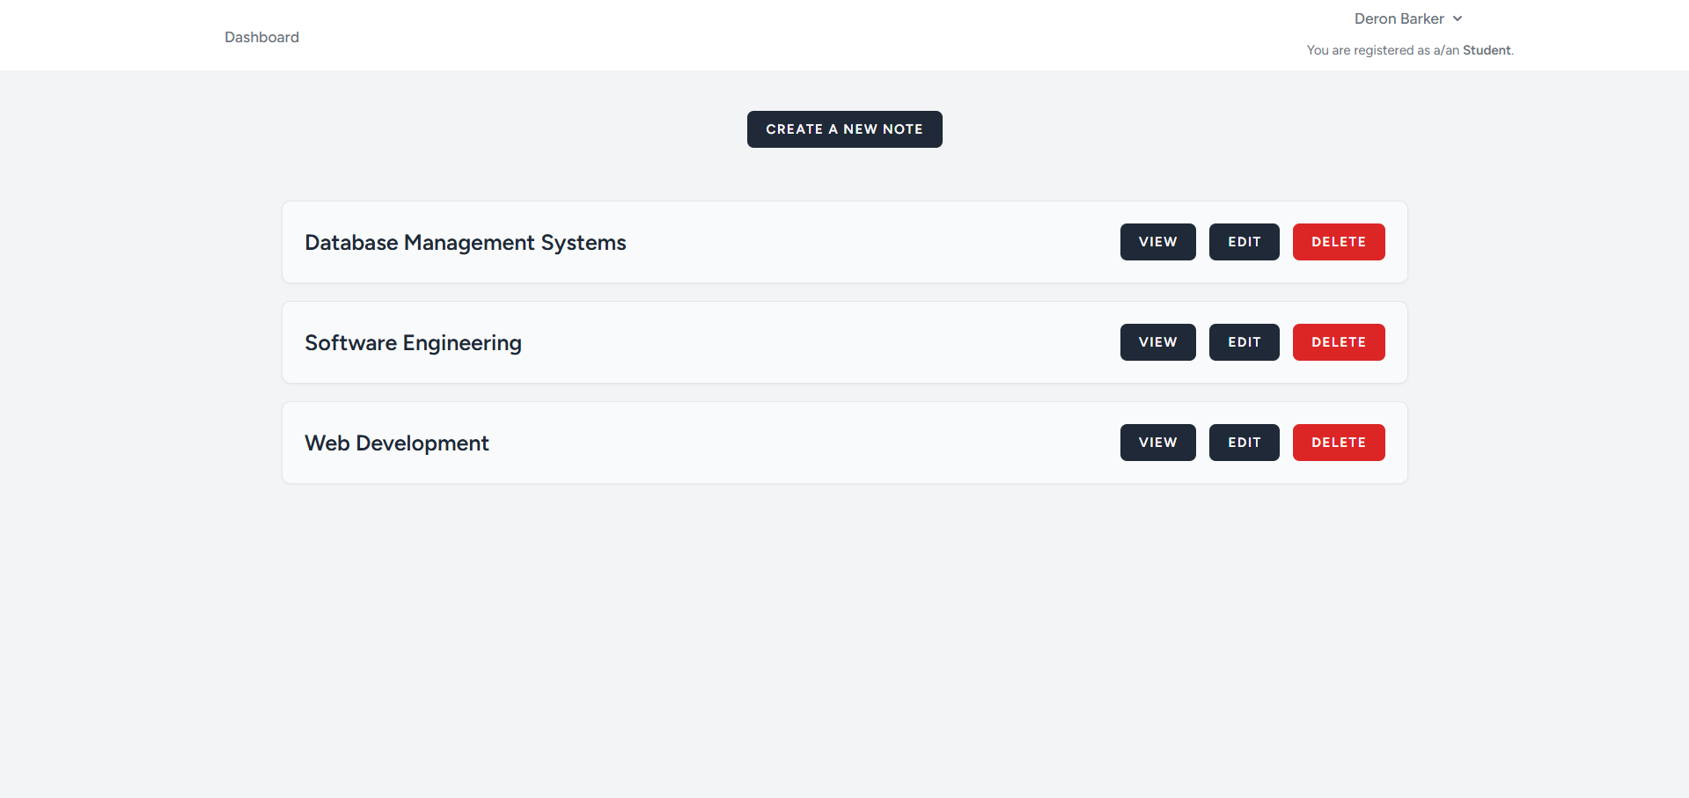
Figure 5 - Index Page
Displays a list of all notes available to the user, including course names and content snippets.

Web Route
HTTP Verb | Path URL | Method | Action
GET | /note | Index | List notes in the PNS
GET | /note.create | Create | Display the form that will allow the create of notes in the PNS
GET | /note/{id}/edit | Edit | Display the form that will allow the editing of the note. The fields in this form will be pre-filled with the note information for the given id
DELETE | /note/{id} | Destroy | Delete the note with the given id
POST | /note | Store | Add a new to the database (the result of submitting the create note form)
GET | /note/{id} | Show | Show note with the given id
PUT/PATCH | /note/{id} | Update | Update the note with the given id (the result of submitting the edit note form)
Table 1 - Web Route
Database Design
A single table named notes will be used to store notes in the PNS. The fields in this are are notes (id, course_name, content).
Notes | Type | Description
Id | Unsigned BigInt | Primary Key
course_name | String
content | String
Table 2 - Database Design for Notes Table
A single field named role will be added to the users table to allow the required role functionality to be added to PNS. Importantly, a user is only allowed to assume one role at a given time.
Notes | Type | Description
Role | String | Assigns a role to the given user. Permissible roles are Student and IT Staff. By default, when a user registers, they will be assigned the role Student. A seeder will be used to create IT Staff.
Table 3 - Database Design for Users Table
Component Level Design
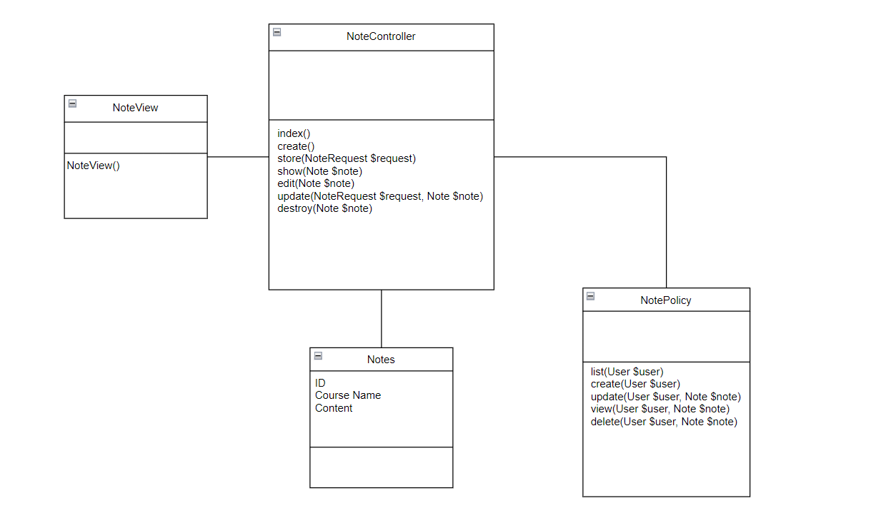
Figure 6 - Component Level Design for Notes

